**ASSIGNMENT 2**

**Version Control System**



**Name**

Sherly Lutfi Azkiah Sulistyawati

**NIM**

2341720241

**Class**

1I

**Department**

Information Technology

**Study Program**

D4 Informatics Engineering

* Please look for 5 **open-source** repositories with the **highest number** of contributors, stars and commits!

1. **freeCodeCamp** (<https://github.com/freeCodeCamp/freeCodeCamp>)

freeCodeCamp is the most starred repository on GitHub. It is the backend for the main freeCodeCamp website that offers numerous free computer science learning materials. These include over 9,000 tutorials and 11 core certifications, ranging from responsive web design to machine learning with Python.

1. **Free Programming Books** (<https://github.com/EbookFoundation/free-programming-books>)

Run by the Free Ebook Foundation, it provides a comprehensive list of free learning resources in numerous languages. In addition to books, this project maintains a list of other educational materials like free online courses, cheat sheets, podcasts, screencasts, problem sets, and code playgrounds.

1. **Awesome** (<https://github.com/sindresorhus/awesome>)

The Awesome repository is a community of knowledgeable or passionate people that curate lists on various topics, from programming to entertainment, to help others learn. Each list contains recommended items like websites, resources, apps, templates, events, companies, organizations, TV shows, movies, and books.

1. **Coding Interview University** (<https://github.com/jwasham/coding-interview-university>)

The Coding Interview University repository by jwasham is a computer science study plan for those interested in pursuing a career as a software engineer. The plan contains carefully curated study materials like books, practice websites, and video tutorials. It also includes tips and tricks on updating your resume, finding a software engineering job, and preparing for a technical interview.

1. **Public APIs** (<https://github.com/public-apis/public-apis>)

This popular GitHub repository contains a list of free Application Programming Interfaces (APIs) developers can use in web and software development. There are over 1,400 APIs available, divided into 50 categories. Examples of the categories include animal, finance, and photography. These APIs serve a wide range of purposes. For example, FishWatch provides information and photos of various fish, while PhotoRoom removes backgrounds from images.

* Create a **daily activity** using a kanban board for 4 weeks (2 weeks back and 2 weeks ahead), at least the kanban structure consists of **To Do, In Progress,** and **Done**!

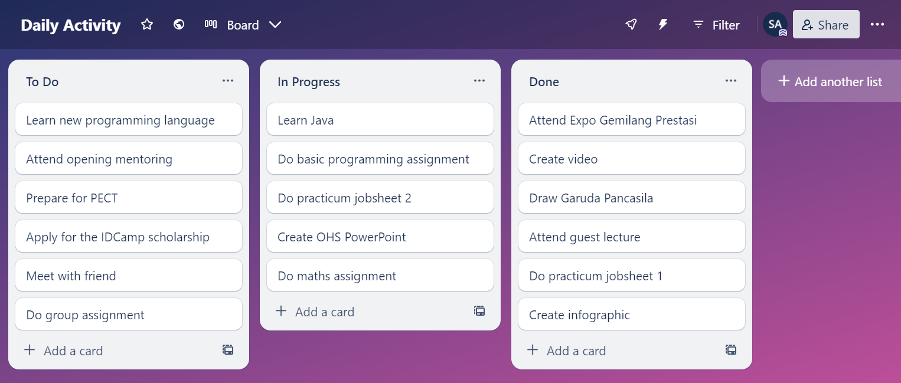

<https://trello.com/invite/b/hB5ovphh/ATTIf776f9718c22bad273f7811826399084018FD71F/daily-activity>